Module 4

- A.Digit Sum | Practice Problems
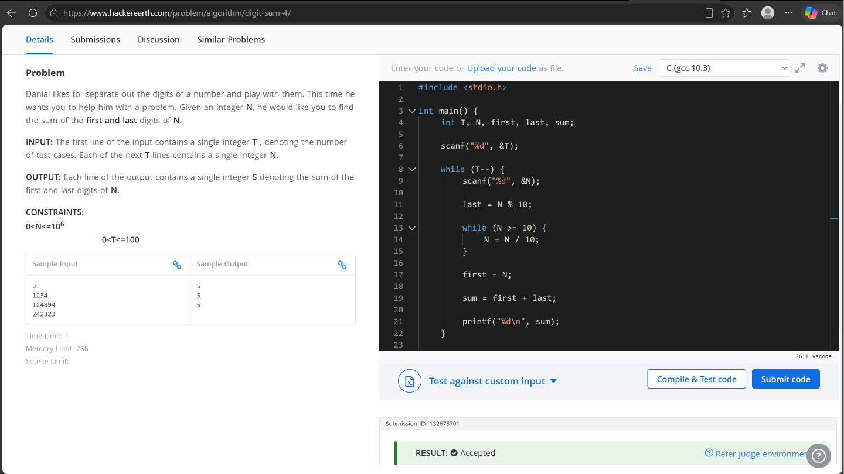

- Find Digits | HackerRank
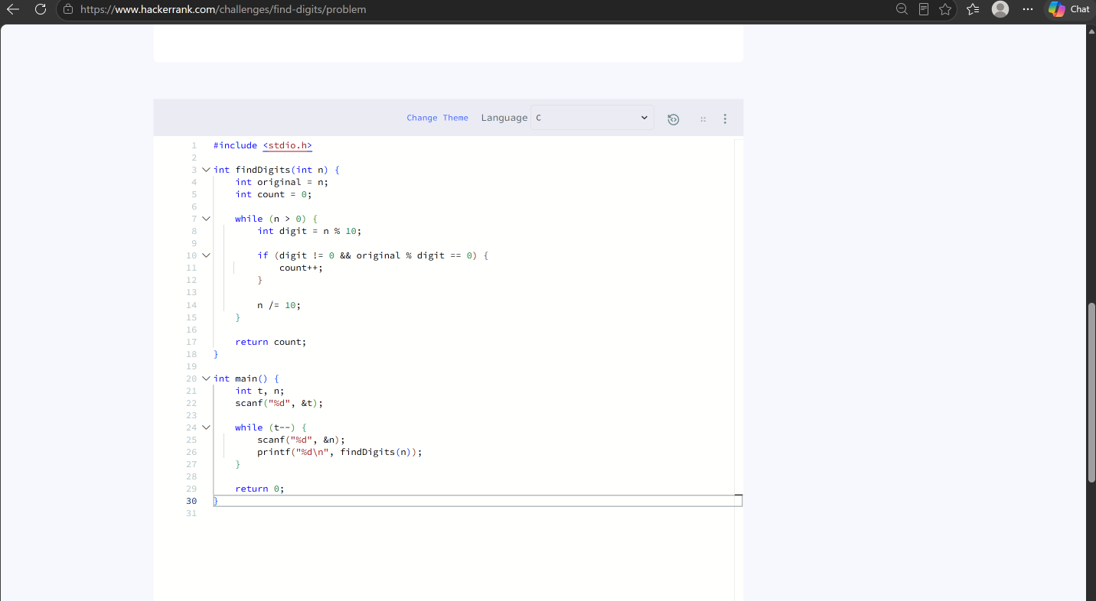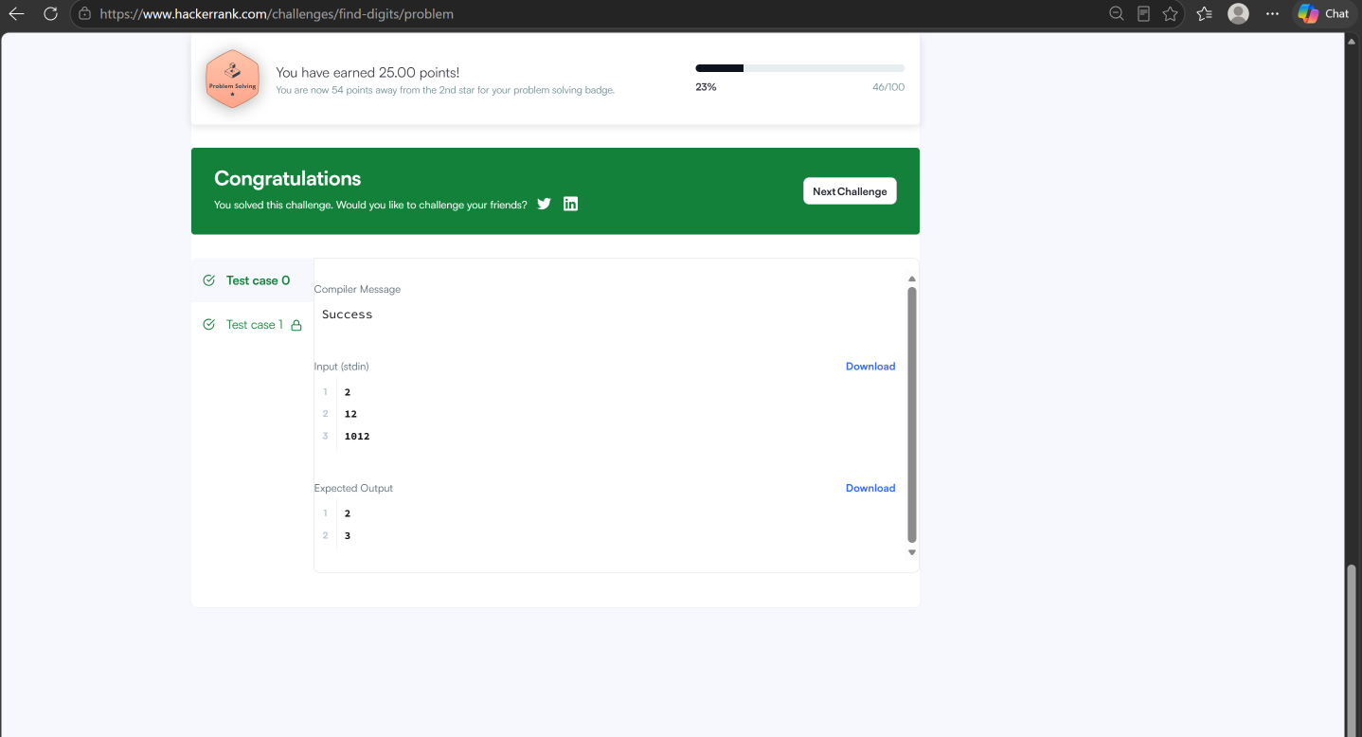

- Subtract the Product and Sum of Digits of an Integer - LeetCode

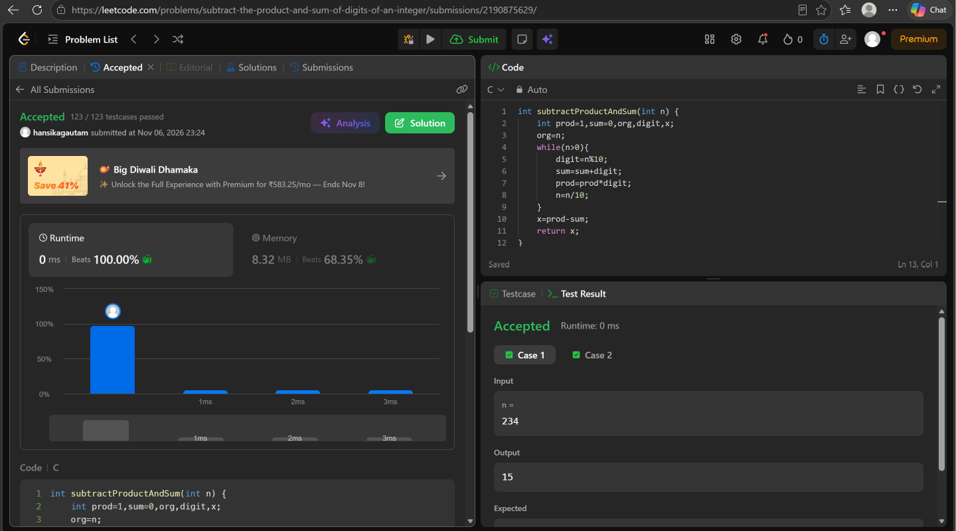

4. Count the Digits That Divide a Number - LeetCode
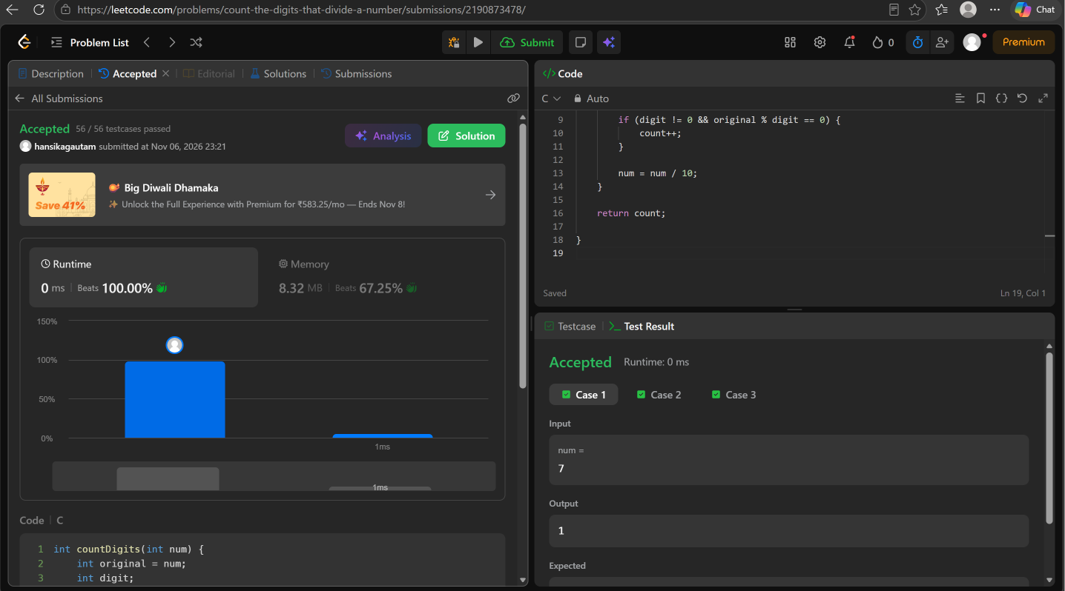

5 . Palindrome Number - LeetCode
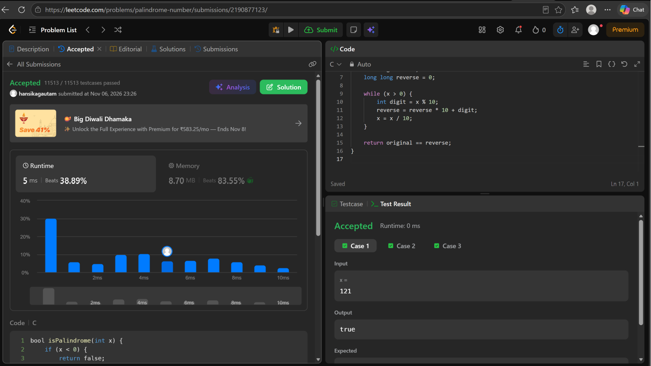

6. Reverse Integer - LeetCode


